Hey Reader!

Welcome back this is your Goppi V P. we are going to study about about my second day lessons of introduction to embedded systems

1. **Resistor**

First of all, what is a resistor?

**Definition**:

Resistor is a passive component which limits the current and divides the voltage.

**Example:**

If you don’t understand, for example you can imagine a tap flowing a water on a full force if you close the tap slowly the flow of water is also reduces. the water is current and the tap is resistance if you increase the resistance the current decreases.

**Formula:**

To find the resistance the we have studied the topic called ohms law

by ohms law,

V=I×R $↔$ R=V/I

**Example,**

V=5 volts, I=0.5amps

R=5/0.5=100Ω

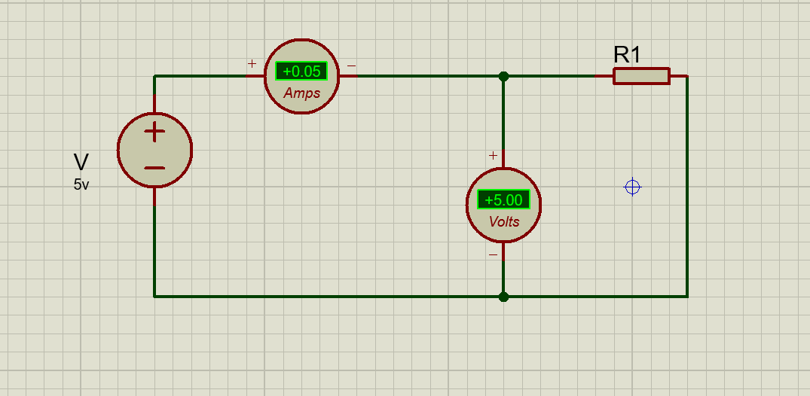

**Types**:

* Fixed Resistor
* Variable Resistor (Potentiometer)
* Special Resistors (Thermistors, LDR)

**How to identify a resistor?**

By using color coding refer the below image (or) use the website [**resistorcolorcodecalc.com**](resistorcolorcodecalc.com)

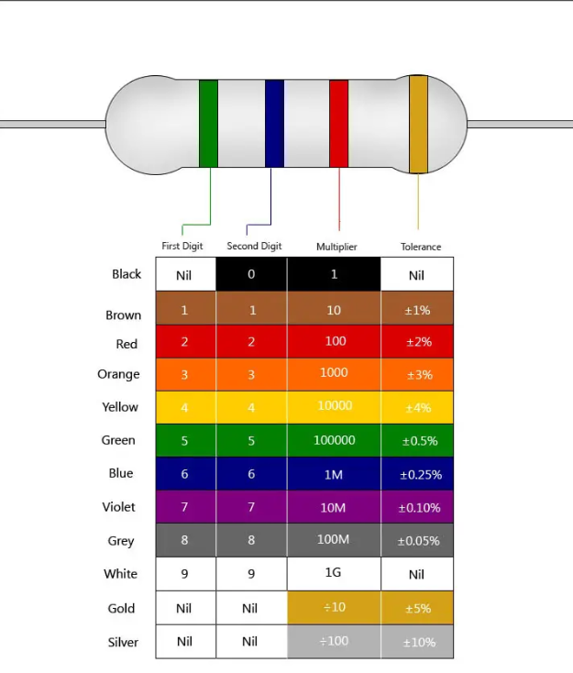

I think you understand what is resistor and how to identify it, let’s we move on to the topic inductor

1. **Inductor**

**Definition**: An inductor is a passive electrical component that stores energy in a magnetic field when electric current flows through it.